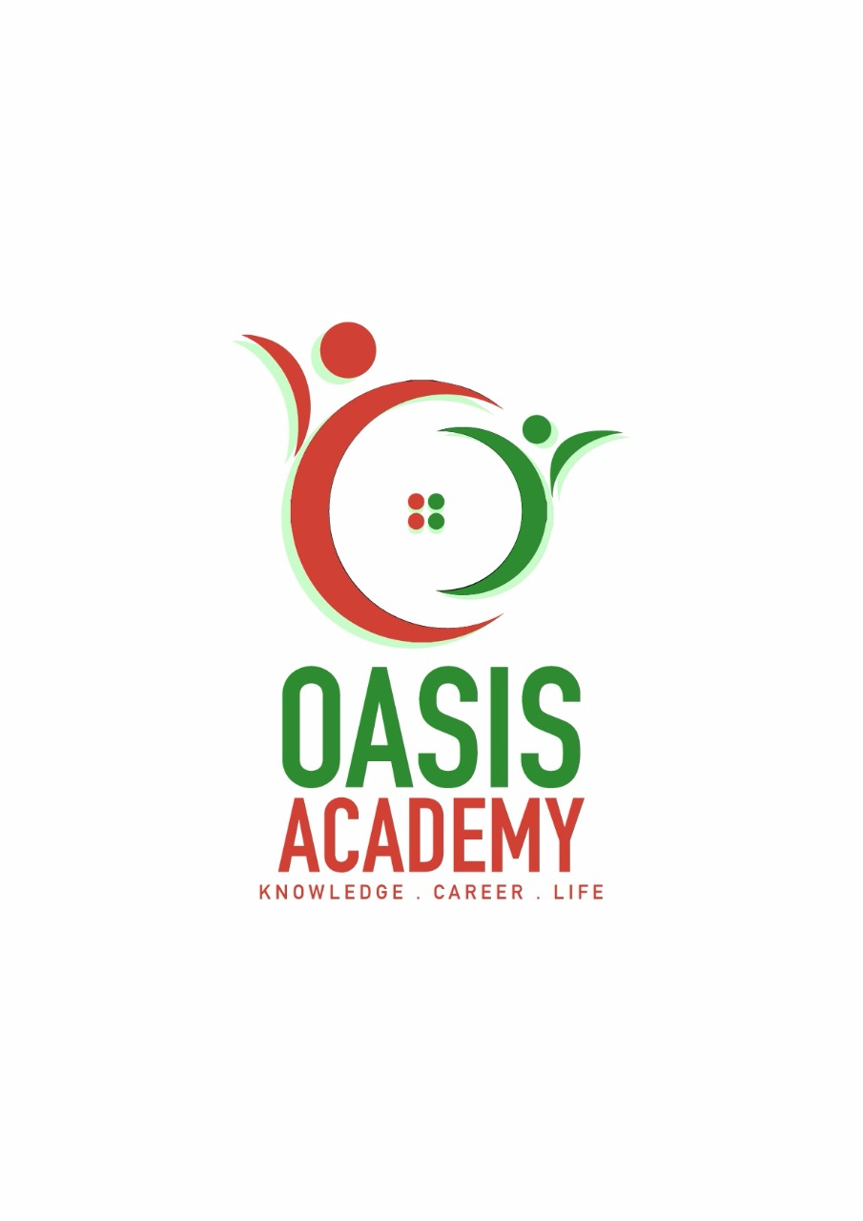

Name : Navin Raj Vijeyaindran

Login ID :

Course Tittle :

Subject Code :

Submitted date:

**Table of Contents**

|  |  |  |
| --- | --- | --- |
| No | Details | Page |
| 1 | Executive Summary | 2 |
| 2 | aaIntroduction | 3 |
| 3 | Assignment Question | 5 - 22 |
|  | Question 1 | 4 - 8 |
|  | Question 2 | 9 - 11 |
|  | Question 3 | 12 - 20 |
|  | Question 4 | 21 - 24 |
| 4 | Conclusion | 25 |
| 5 | References | 26 -27 |

**Executive Summary**

In this assignment, firstly i have learned the recruitment process and also Human Resources Operation which is helps to selected a best and quality employees.

Secondly, Human Resources Planing and Trend in Hospitality, it will make the organization reach the desired manpower position from the current manpower position, by forecasting the demand for and supply of human resources in the near future.

Thirdly, Human Resources Functions and Human Resources Policies. In this part, i learned about what is functions of management and the law of workplaces. By this i can understand about strategic of company.

Lastly, Organizational Behavior and Structure Organization in Hospitality Industry. Its helps to me learned how to communicated with costumer and the way we treat. We want give most important to our attitude.

**Introduction**

**Assignment Questions**

**Question 1**

**In a brief but comprehensive response, define the role of accounting.**

**The Role Of Accounting**

Accounting is system which records of financial transactions and reports of such transactions and for decision making purpose.As such it can be seen that the main role of accounting is to assist for better decision making. The type of decision varies from a business to another business – in terms of nature, size, location and form.Below is a list of **some** of the role of accounting in the decision making process.

*it allows

**Traning**

Traning is any attempt to improve current or future employee performance by increasing an employee’s ability to perform through learning, usually by changing the employee’s attitude or increasing his or her skills and knowledge.

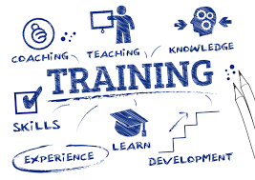

**Motivation**

Motivation is the inner drive that direct a person’s behavior toward goals. Motivation can be defined as a process which energizes,directs and sustains human behavior. In HRM the term refers to person’s desire to do the best possible job or to exert the maximum effort to perform assigned tasks. An important feature of motivation is that it is behavior directed towards goal.

 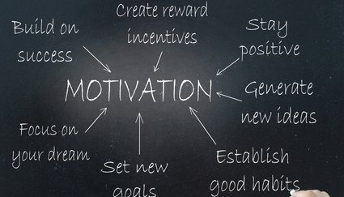

**Evolution**

Evolution is the structured interpretation and giving of meaning to predicted or actual impacts of proposals or results. It look at original objectives and at what is either predicated or what and how was accomplished. So evaluation can be formative that is talking place during the development of concept or proposal, project or organization with the intention of improving the value or effectiveness of the proposal, project or organization.

 

**Compensation**

Compensation It can be defined as all of the rewards earned by employees in return for their labour. Its also includes Direct and Indirect Financial Compensation and also Non-Financial Compensation.



**Human Resources Operation in Hospitality Management is Requirements.**

The Degree holders preferably in HRM or related disciplines and also the require minimum 8-10 years’ relevant supervisory experience gained from a sizable organization and past paced environment .Hands-on HR generalist experience in the hospitality or travel industry preferably. Than, they need experience in setting up HR policies and processes is a definite advantage and also person who independent, proactive, responsible, result-oriented, detail-minded and able to work under pressure. After that, the staff also want to be good team player with commitment to quality work and tight schedule. Finally the HR Operation require staff who excellent in verbal communication and writing skill and also Global Skills.

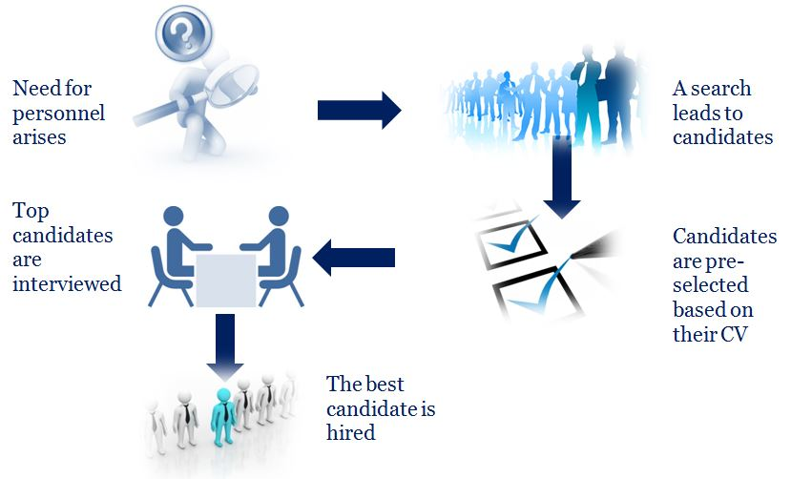

**Question 2**

Describe In Brief On Human Resources Planning And Planning Trend In Hospitality.

Explain about what is your understanding on Action Plan Human Resource Planning in Hotel Industry.

**Brief Of Human Resource Planning**

HRP is continuous process of systematic planning to achieve optimum use of an organization’s most valuable asset. The objective of human resource planning is to ensure the best fit between employees and jobs while avoiding manpower shortages or surpluses. The four keys steps of the human resource planning process an analyzing present labor supply, forcasting labor demand, balancing projected labor demand with supply and supporting organizational goals.

**Human Resource Planning Trend in Hospitality Management**

**Collabroration**

Collabroration joint activities of people or companies aimed at achieving common goals.

**Companies**

Companies that are Not Focused or Hotel Business entering Hotel Market which is due the fact that hotel business is more adaptive to external environment than any other industry it becomes highly popular among companies that are not focused directly on hotel business.

**Opening Hotels on behalf of Well-Known Brands**

The trend of opening hotels on behalf of fashion brands is still under way. After that, Management under Large Hotel Operators its means world’s largest hotel groups close deals and buy hotels all over the world to expand their chains. Both luxury hotels and lower class hotels attract attention of hotel operators.

**Exclusive Luxury and Customized Services**

Well-known name supported by world quality standards is not enough to make a hotel project successful and also new hotel industry trends must be taken into account. Staff in such hotels does its best to offer guests exclusive luxury and best services. Attention to such hotels from well-known chains and big companies proves that hotels are really popular.

**Action Plan Of HRP In Hotel Industry**

In my understanding Action Plan HR in Hotel Industry is important to any organization and its success because it forms an integral parts of the organization and also ensure that the organization succeed in achieving all its defined goals and targets.

Firstly, the systematic evaluation of HR needs that makes sure that the accurate number of employees with the most suitable skills are readily available whenever they are required. In the process of HR planning, it is required of the practitioners that the objectives needed to be achieved must be in mind. This is the exact reason why many job seekers keep seeking employment. When these requirements are neglected by an organization’s authorities, there are possibilities of poor performances and even other industrial issues within the organization.

Furthermore, another important aspect of planning for human resources is the forecasting demand. Its is imperative that the practitioners fully have some idea of where the organization is headed with its sales and revenue. The percentage of sales in the current year should be better than the previous year. The new recruiting of new staff to the organization can help to meet this demand. Basically, the need for employees who will help meet some financial demands is necessary here. Otherwise, customers may see the organization not effectively carrying out their business success.

Finally, being proactive is another aspect of Action Plan HR in Hotel Industry. Bearing in mind the idea of being proactive in business will help keep hands-up with what the business process and this build more effective method to create a pipeline of employees that are ready, unforced and able to help the organization grow and attain its goals. When employees see some excitement in the management on the foreseen success, they will also be excited about the future of the organization and also about the new talent that would be brought on-board, this will make them excited to help the organization reach their goals.

**Question 3**

Brief About Human Resources Functions And Human Resources Policies.

Describe The Functions Of Management And How The Policy Applies Accordingly In Hospitality Management.

**Brief About HR Functions**

**Recruitment**

* The success of recruiters and employment specialists generally is measured by the number of positions they fill and the time it takes to fill those positions.



**Safety**

* Workplace safety is an important factor. Under the Occupational Safety and Health, employers have an obligation to provide a safe working environment for employees.



**Employee Relation**

* In a unionized work environment the employee and labor relations functions of HR may be combined and handled by one specialist or be entirely separate functions managed by two HR specialists with specific expertise in each area.



**Compensation and Benefits**

* Like employee and labor relations, the compensation and benefits functions of HR often can be handled by one HR specialist with dual expertise.

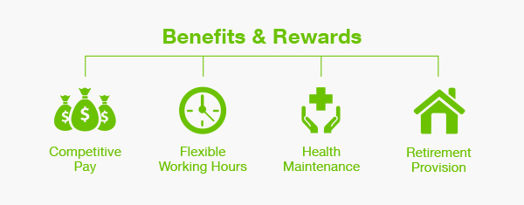

**Compliance**

* Compliance with labor and employment laws is a critical HR function. Noncompliance can result in workplace complaints based on unfair employment practices, unsafe working conditions and general dissatisfaction with working conditions that ca affect productivity and ultimately, profitability.



**Traning and Development**

* Employers must provide employees with the tools necessary for their success which in many cases.It means giving new employees extensive orientation training to help them transition into a new organizational culture.



**Brief About HR Policies**

**Organizational Structure**

Each organization designs its organizational structure differently and uses different approaches to set the right level of managerial layers and the way of cooperation between HR Front Office, HR Back Office and HR Centers of Excellence.



**Legal Issues**

HR issues when putting together their personnel policies :

* Equal Employment Opportunity Policies
* Employee classifications
* Workdays, paydays and pay advances
* Overtime compensation
* Meal periods and break periods
* Payroll deduction
* Vacation policies
* Holidays
* Sick days and personal leave ( for bereavement, jury duty, voting, etc )
* Performance evaluations and salary increases
* Performance Improvement
* Termination policies



**Supervision Guide**

Supervision is workplace activity in which a manager oversees the activities and responsibilities of employees he manages. It is an important job function for managers at all levels throughout the company. Coaching, training and employee development are among the common responsibilities assumed by a supervisor.

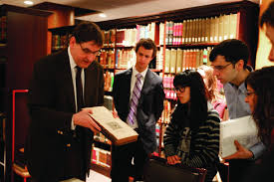

**Consistency**

In a hectic workplace, creation consistency can present a challenge. Working to establish a workplace in which policies, procedures and practices are consistent however, has it benefits. There are a numberof reasons why consistency is a goal toward which you should work.

**The Functions of Management and How the Policy applies accordingly in Hospitality Management.**

Functions of Management firstly is recruitment. Recruitment is the process of captivating, screening and selecting potential and qualified candidates based on objective criteria for a particular job. The goal of this process is to attract the qualified applications and to encourage the unqualified applicants to opt themselves out. Before starting the process of recruitment, the companies must execute proper staffing plans and should grade the number of employees they are going to need. Forecasting of the employees should depend upon the annual budget of the organization and short-term and long-term goals of the organization. Secondly, one of the main functions of HR is to support workplace safety training and maintain federally mandated logs for workplace injury and fatality reporting. HR safety and risk specialists often work closely with HR benefits specialists to manage the company’s workers compensation issues.

Third, Function is Employee Relations; the HR discipline concerned with strengthening the employer and employee relationship through measuring job satisfaction also employee engagement and resolving workplace conflict.Labor relations functions may include developing management response to union organizing campaigns, negotiating collective bargaining agreements and rendering interpretations of labor union contact issues. Fourthly, Compensation and Benefits. On the compensation side, the HR functions include setting compensation structures and evaluating competitive pay practices. A comp and benefits specialist also may negotiate group health coverage rates with inurers and coordinate activities with the retirement savings fund administrator. Payroll can be a component of the compensation and benefits section of HR.

Fifth Function of HR Management is Compliance. HR staff must be aware of federal and state employment laws such as Title VII of the Civil Rights Act, the Fair Labor Standards Act, the National Labor Relations Act and many other rules and regulations. Last point of Function of HRM is Training and Development. HR department also provide leadership training and professional development. Leadership training may be required of newly hired and promoted supervisors and managers on topics such as performance management and how to handle employee relations matters at the department level. Professional development opportunities are for employees looking for promotional opportunities or employees who want to achieve personal goals such has finishing a college degree.

The Policy Applies accordingly in Hospitality Management is Organizational Structure. Most HR Functions operator similar pressures from stakeholders. The top management demands the execution of the business strategy and the HR Strategy. The line management demands the perfect support from HR Processes. Employees demands a quality of employee services. HR has many stakeholders and the HR Organizational Structure has to fit with all requests. After that, Legal issues which is related to Labor and Employment law and encompasses the various laws and regulations specific to HR professionals. It deals with the issues that HR professionals must contend with in the majority of their work functions, predominantly in overseeing and managing duties related to hiring, firing, employee benefits, wages, paychecks and overtime.

Furthermore, Supervision Guide. Supervisors play a pivotal role in the under their supervision. Leadership, training, employee morale and task direction are among the central responsibilities of effective supervisors. Relationship between supervisors and their employees provide much of the influence in good organizational communication. Workplace conflict is common in organizations. Employees that work together in close proximity everyday can sometimes get into heated disagreements. Supervisors do make mistakes. Just as supervision can have positive effects in your organization, it can also cause damage if manager abuse or misuse their influence. Lastly, Consistency. Workplaces in which consistency is presents appear better organized than those in which things are constantly changing. Although some individuals don’t mind constant changes, most prefer consistency. When things are constantly changing, employees must take time out of the completion of their jobs duties to learn these new policies and procedures. Keeping up with constantly changing policies and procedures can be mentally taxing.

**Question 4**

Explain in detail about Organizational Behavior in Hospitality and brief on Group and Structure in Organization.

**Organizational Behavior in Hospitality**

The hospitality sector is one of the largest growing industries in the world.

The is reflected in the growing number of academic courses available on the subject. They key element of hospitality management is interaction between the people who work in the industry and the environment in which they work.

In the hospitality industry the employees of various personality join together in performing various job, the organizational behavior emerges as informal or formal behavior of the individual and groups. Here all employees work towards improving organizational behavior. Certainly there are differences between individuals placed in similar situations and also all people do not act alike. There are certain fundamental consistencies underlying the behavior of all individual that can be identified and then modified to reflect individual differences. The responsibility of the HR Department have increased since organizational behavior has never been as important as it is in today’s employment world which is changing dramatically.

Organizational behavior refer to the way individuals and groups interact within and toward an organization. The combined behaviors create a company climate that can bolster or undermine an organization’s success. Operating from within a company’s system, both management and staff might have difficulty recognizing patterns of behavior and also how profoundly those patterns can influence a company’s performance. To make sure that influence is positive, leaders must help others grasp the importance of organizational behaviors so that everyone involved in a company’s future can better understand and shape the internal conditions of an organization.

The hospitality staff has to work with various persons coming from various background, educations, skills, traditions and customs. Cooperation, communication and coordination are the three basic requirements that keep the hospitality industry moving in perfection. Hence every pain is taken by the HRD Department to solve behavioral problem that may appear during the course of the routine and special job functions handled day in and day out.Organizational behavior consists of managerial behavior, individual behavior, group behavior and consumer behavior. All behavior is based on relations, attitudes, working conditions the role of executives and organization atmosphere.



**Brief About Groups and Structure in Organization.**

An organization is a group of people who together work to achieve a common goal. In order to work together efficiently, the group must find the best way to organize the work that needs to be done in order to meet the goals of the organization. Organizational structure defines how tasks are divided, grouped and coordinated in organization. Every organization has a structure that clarifies that roles that organizational members perform, so that everyone understand their responsibilities to the group .

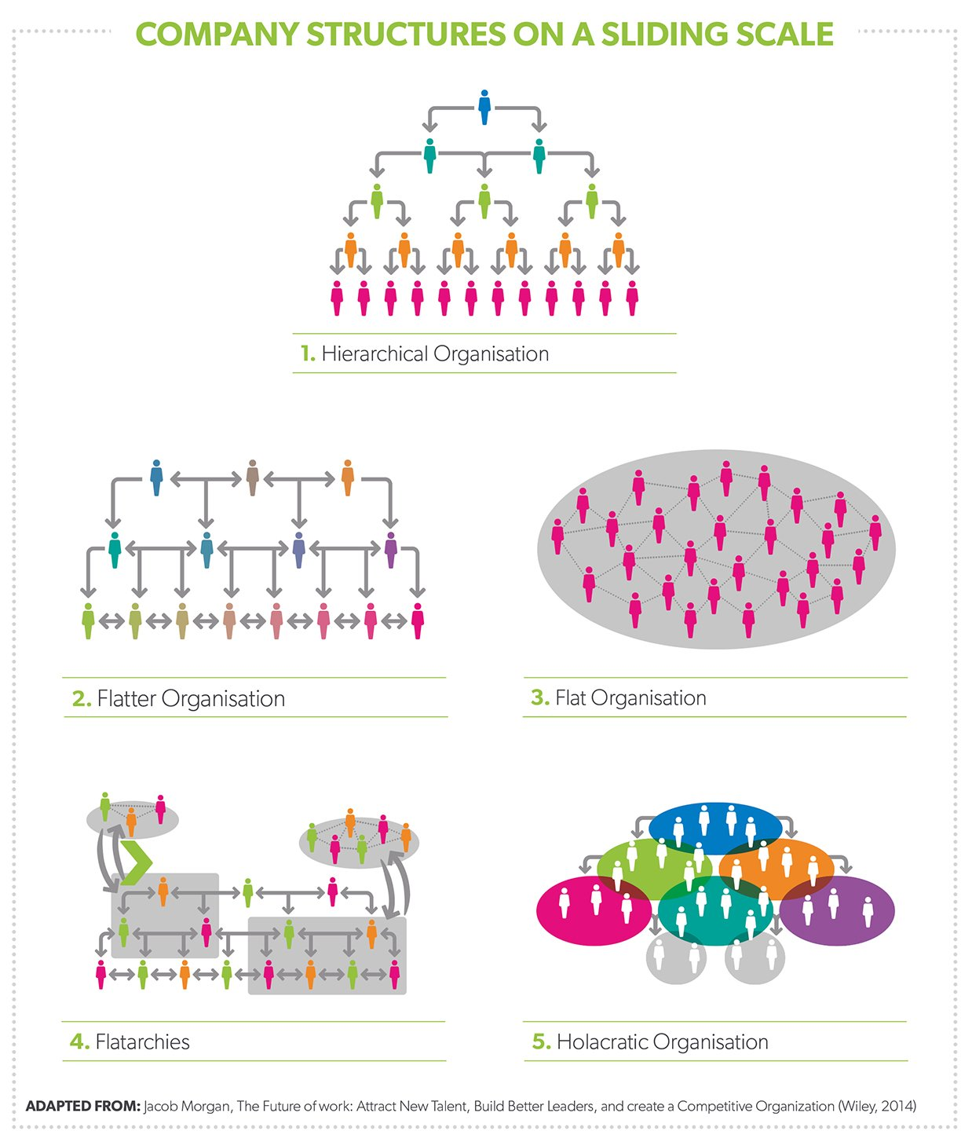

**Conclusion**

Human Resource Management focuses on matching the needs of the business with the needs and development of employees. Tarmac depends on its people because their skills contribute to achieving its business objectives.

Within Tarmac, every employee has a valuable role to play. The emphasis is on helping individuals to work together.Workforce planning is part of this strategic process, which looks at the long-term needs across the organization.

Personal development plans enable every individual to grow both professionally and personally within the business. They also help Tarmac to create a distinct and important competitive advantage through selecting and developing highly motivated and skilled staff who are able to perform at high levels.

**References**

* <https://www.keka.com/5-major-functions-human-resource-management/>
* <http://www.younghrmanager.com/roles-and-functions-of-the-human-resource-department>
* <https://www.brown.edu/about/administration/policies/index.php?q=category/human-resources>
* <https://www.inc.com/encyclopedia/human-resource-policies.html>
* <http://managementhelp.org/supervision/roles.htm>
* <https://www.google.com.sg/search?q=recruitment&source=lnms&tbm=isch&sa=X&ved=0ahUKEwi38pGO0ZnUAhVKP48KHfEcBBsQ_AUICigB&biw=1280&bih=670#tbm=isch&q=recruitment+and+selection&imgrc=_>
* <https://www.google.com.sg/search?q=recruitment&source=lnms&tbm=isch&sa=X&ved=0ahUKEwi38pGO0ZnUAhVKP48KHfEcBBsQ_AUICigB&biw=1280&bih=670#tbm=isch&q=evaluation&imgrc=_>
* <https://www.google.com.sg/search?q=recruitment&source=lnms&tbm=isch&sa=X&ved=0ahUKEwi38pGO0ZnUAhVKP48KHfEcBBsQ_AUICigB&biw=1280&bih=670#tbm=isch&q=compensation>
* <https://www.google.com.sg/search?biw=360&bih=306&tbs=isz%3Al&tbm=isch&sa=1&ei=phs1Wd_qA8rzvASr7p_oDg&q=organizational+behavior+in+hospitality+industry&oq=Organizational+behavior+in+hospita&gs_l=mobile-gws-img.1.0.0i24k1l2.260718.275309.0.276845.35.34.0.1.1.0.275.4626.0j31j3.34.0....0...1.1.64.mobile-gws-img..0.35.4664.3..0j41j0i67k1.xU2xZoaxQ2w#tbs=isz:l&tbm=isch&q=group+and+structure+organization>
* <https://www.google.com.sg/search?q=recruitment&prmd=inmv&source=lnms&tbm=isch&sa=X&ved=0ahUKEwjk95TQq6bUAhUKRI8KHVFxC8sQ_AUICSgB&biw=360&bih=511&dpr=2>
* <https://www.google.com.sg/search?q=safety&prmd=inmv&source=lnms&tbm=isch&sa=X&ved=0ahUKEwjKy8jpq6bUAhWIN48KHdSQBrQQ_AUICSgB&biw=360&bih=511&dpr=2>
* <https://www.google.com.sg/search?q=organizational+behavior+in+hospitality+industry&source=lnms&tbm=isch>